Epsom & Ewell
10
v
Kensington Borough
Saturday, 17th November 2018 – 3.00 p.m.
Good afternoon! We welcome the players, supporters and officials of Kensington Borough as they make their first ever visit to High Road for today’s important League match. This is an important match for both clubs as we need the points to put pressure on the teams above us, while our opponents will be looking over their shoulders, as they are not that far from the relegation places.

However, it is now quite possible that no clubs will now be relegated this season, as we started the season one team short of the full complement of twenty and in the last few days have heard rumours that AC London are to be removed from the League. They were voted out by the clubs at the start of the season but appealed and apparently that appeal has now failed. This is unconfirmed by the League as I write this, so will not amend the tables until we hear officially.

I should place on record that we never had an issue with AC London but are well aware that a few other clubs did. Our 6-0 win there appears likely to be removed from the League records, but I can confirm that all players who played or scored will retain those stats in our Club records regardless of the outcome, as it was at the time an official competitive match.

We were last in action at High Road against a very good Sandhurst Town side in the Division One League Cup. They had won their previous six matches, and we weathered a very tough first half before coming through 1-0 in extra time. Both this competition and the League Cup, in which we retain an interest are to be drawn this coming Monday and we hope to have that information on Tuesday, so keep checking the website or our Twitter page for more details.

We followed that result with a 2-1 victory over Ash United at Youngs Drive which was hard fought and well earned. It is also worth noting that we have played just five League matches at home, but ten away before we kick off today.

We host Dorkinian FC here on Tuesday as we attempt to make further progress in the Surrey Premier Cup. They are an Amateur Football Combination team, sitting fourth in the Premier Division and will be no pushovers. We then make our first ever visit to Eversley & California on Saturday before returning here ten days today for our return League match with Dorking Wanderers Reserves. Why not come along and follow the Salts as we need your support!

Finally, we are pleased to announce that Simon Funnell has been confirmed as our new Manager following a successful trial period, during which we have won our last five matches. We wish him and new Assistant Matt Drew well for the rest of the season. They want promotion and so do we!

Enjoy the game.

Rich

You can follow us on Facebook: www.facebook.com/epsomandewellfc
Twitter: @EEFCOfficial Instagram at: www.instagram.com/epsomandewellfc
and Youtube at: www.youtube.com/channel/UCtLrpS0x5OaYUACRT34_zng

Cover photos by Gemma Jarman

- Bobby Bennett scores his seventh penalty of the season as he strikes our second goal from the spot at Ash United in our 2-1 win last Saturday

Cherry Red Records Combined Counties League
Division One Table 2018/19
inc Tuesday 13th November 2018 | P | W | D | L | F | A | Pts | GD | H | A
Bedfont & Feltham | 14 | 10 | 3 | 10 | 49 | 12 | 33 | +37 | 8/12 | 13/4
Sheerwater | 16 | 10 | 3 | 3 | 36 | 21 | 33 | +15 | 2-3 | 22/12
Farnham Town | 15 | 9 | 3 | 3 | 32 | 13 | 30 | +19 | 2/2 | 1-4
Epsom & Ewell | 15 | 10 | 0 | 5 | 41 | 24 | 30 | +17 | X | X
AC London | 15 | 9 | 2 | 4 | 36 | 25 | 29 | +11 | 2/3 | 6-0
Frimley Green | 15 | 8 | 5 | 2 | 27 | 21 | 29 | +6 | 3-0 | 23/2
Sandhurst Town | 14 | 8 | 3 | 3 | 25 | 24 | 24 | +1 | 20/4 | 2-0
Tooting Bec | 16 | 8 | 2 | 6 | 32 | 25 | 26 | +7 | 3-1 | 30/3
Ash United | 15 | 7 | 4 | 4 | 42 | 29 | 25 | +13 | 12/1 | 2-1
Dorking Wanderers Res | 16 | 7 | 4 | 5 | 36 | 33 | 25 | +3 | 27/11 | 3-5
British Airways | 17 | 6 | 4 | 7 | 37 | 39 | 22 | -2 | 16/2 | 2-3
Chessington & Hook Utd | 15 | 6 | 2 | 7 | 29 | 33 | 20 | -4 | 1-2 | 4-1
Eversley & California | 13 | 5 | 0 | 8 | 28 | 32 | 15 | -4 | 29/12 | 24/11
Godalming Town | 13 | 3 | 2 | 8 | 16 | 30 | 11 | -14 | 1/12 | 26/1
Kensington Borough | 15 | 3 | 2 | 10 | 22 | 40 | 11 | -18 | 17/11 | 9/3
Bagshot | 16 | 3 | 2 | 11 | 16 | 61 | 11 | -45 | 19/1 | 3-0
Fleet Spurs | 13 | 3 | 0 | 10 | 23 | 36 | 9 | -13 | 6/4 | 3-2
FC Deportivo Galicia | 14 | 2 | 2 | 10 | 20 | 28 | 8 | -8 | 12/3 | 3-0
Cove | 13 | 1 | 1 | 11 | 16 | 37 | 4 | -21 | 3-2 | 5/1

Lucky Day? – 17th November
Played 15 - Won 8 Drawn 2 Lost 5 - For 38 Against 25 - PPG 1.73 - Good
Our Club record against Kensington Borough
The two clubs have never played
Kensington Borough ‘s last visit
This is their first visit

Our New Club Manager - Simon Funnell
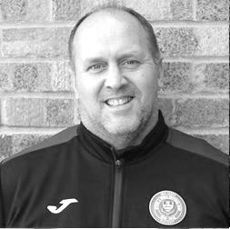
Good afternoon everybody!

I was delighted to get the news that I was given the chance to take the job on permanently after five games in the Caretaker role losing just one and winning four.

Since I have taken over we have been working hard on the training ground with the players and I am delighted with them as we have asked them to take a lot on board and they have done that and I think it is starting to show in our recent results.

On the player front we have welcomed Jamie Watts to the squad from Chessington & Hook United and Roy Gayle from Guildford City. I’m hoping to possibly bring one or two players in over the coming weeks.

On the injury front Taryn Smith is still a little way off being fit and Ryan Sullivan was rested last weekend to give a little knock a chance to recover, although David Jones who got injured last Saturday away to Ash United has ankle ligament damage and will be out for a few weeks, but it could have been a lot worse and for that we are all pleased for David.

I am also delighted to announce that Matt Drew will be coming on board as my Coach/Assistant. Matt is a very important part of the Management team and I have worked with him for many years now. He is a great addition to the club. On the Physio front we will be doing all we can to bring one in ASAP.

The aim for the rest of the season would obviously be to get promoted, but for now let’s take one game at a time and see where it takes us.

Hope you all enjoy the game this afternoon.

Simon

Surrey Premier Cup
First Round
Carshalton Athletic U19 | w/o Ash | Ash United
Shene Old Grammarians | 2-4 | Old Wilsonians
Lingfield | 5-1 | Horley Town Reserves
Alfold | 2-0 | Godalming Town
Epsom & Ewell | 5-0 | Knaphill U23
Reigatians | 0-4 | Frimley Green
Met Police Reserves | 5/12 | FC Deportivo Galicia
Second Round
Ash United | 20/11 | Chessington & Hook United
Alfold | 27/11 | Nottsborough (holders)
Old Wilsonians | 4/12 | Lingfield
Sheerwater | 1/12 | Corinthian Casuals Reserves
Farnham Town | 20/11 | Westfield Reserves
Epsom & Ewell | 20/11 | Dorkinians
Met Police Res / FC Deportivo Galicia | V | Dorking Wanderers Res
Bagshot | 1/12 | Frimley Green

Recent Results and Fixtures
Esoteric Division One Cup Second Round – Tuesday 6th November
Epsom & Ewell | 1-0+ | Sandhurst Town
Sheerwater | 2-3 | Chessington & Hook United
Combined Counties League – Tuesday 6th November
Ash United | 5-0 | FC Deportivo Galicia
Eversley & California | 5-1 | Godalming Town
Kensington Borough | 1-4 | Bagshot
Tooting Bec | 3-0 | Bedfont & Feltham
Combined Counties League – Saturday 10th November
Ash United | 1-2 | Epsom & Ewell
British Airways | 1-2 | Tooting Bec
Eversley & California | 2-0 ABAN 61 | Chessington & Hook United
Frimley Green | 3-2 | Dorking Wanderers Reserves
Sandhurst Town | 2-0 | Sheerwater
Combined Counties League Cup – Second Round – Monday 12th November
Sutton Common Rovers | 4-2 | Southall
Combined Counties League Cup – Second Round – Tuesday 13th November
CB Hounslow United | 4-1 | Badshot Lea
Chertsey Town | 3-2 | British Airways
Cobham | 0-3 ABAN 88 | AFC Hayes
Abandoned after 88 minutes following a serious injury to an AFC Hayes player
Hanworth Villa | 2-1 | Sandhurst Town
Esoteric Division One Cup 2nd Round – Tuesday 13th November
Kensington Borough | 0-2 | FC Deportivo Galicia
Combined Counties League – Saturday 17th November
Bagshot | V | Dorking Wanderers Reserves
Bedfont & Feltham | V | Cove
Chessington & Hook United | V | AC London
Epsom & Ewell | V | Kensington Borough
FC Deportivo Galicia | V | Eversley & California
Frimley Green | V | Ash United
Godalming Town | V | Farnham Town
Sheerwater | V | Fleet Spurs
Tooting Bec | V | Sandhurst Town
Recent Results and Fixtures
Combined Counties League – Saturday 24th November
AC London | V | Sheerwater
British Airways | V | Fleet Spurs
Cove | V | FC Deportivo Galicia
Dorking Wanderers Reserves | V | Ash United
Eversley & California | V | Epsom & Ewell
Farnham Town | V | Bedfont & Feltham
Godalming Town | V | Chessington & Hook United
Kensington Borough | V | Frimley Green
Sandhurst Town | V | Bagshot
Combined Counties League – Tuesday 27th November
Epsom & Ewell | V | Dorking Wanderers Res
Tooting Bec | V | AC London
Combined Counties League – Saturday 1st December
Ash United | V | Sandhurst Town
Bagshot | V | British Airways
Bedfont & Feltham | V | AC London
Chessington & Hook United | V | Farnham Town
Epsom & Ewell | V | Godalming Town
FC Deportivo Galicia | V | Frimley Green
Fleet Spurs | V | Cove
Kensington Borough | V | Eversley & California
Tooting Bec | V | Sheerwater

Esoteric League Division One Challenge Cup
First Round
Farnham Town | 0-1 | Godalming Town
Cove | 2-1 | British Airways
FC Deportivo Galicia | 2-1 | AC London
Second Round
Eversley & California | 2-3 | Bedfont & Feltham
Epsom & Ewell | 1-0 | Sandhurst Town
Tooting Bec | 4-1 | Ash United
Kensington Borough | 0-2 | FC Deportivo Galicia
Sheerwater | 2-3 | Chessington & Hook United
Fleet Spurs | 0-0 - 4-3p | Cove
Dorking Wanderers | 1-2 | Frimley Green
Godalming Town | 6-0 | Bagshot

From behind the goal
Epsom & Ewell 3-0 Frimley Green
Combined Counties League - Division One - Saturday 3rd November 2018

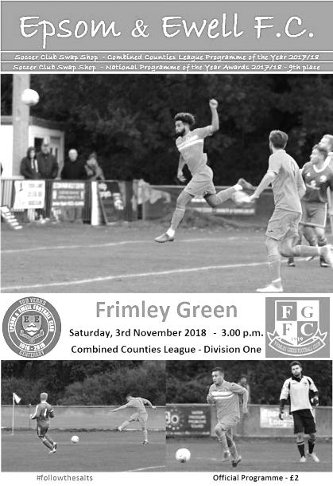
Salts in control and make Frimley look Green

Despite three suspensions, including inspirational and ever-present skipper Scott Murphy, our boys worked hard to contain Frimley Green's threat before taking full charge with three goals midway through the match. From that platform we then produced a show of defensive stability as we had to battle with ten men for the last half hour, which left the visitors looking quite average by the end of the match and handing them only their second League defeat of the season in the process.

Whilst admitting that the opposition were also missing their Captain for this encounter and then got off to a bad start in arriving without their kit, which finally showed at around 2.20, our boys would prove to be almost irresistible at times, led by temporary Captain Adam Heagney who was also making his 100th appearance for our club, and not one Salts player on the field had a bad game, although maybe things might have been different had the visitors taken advantage of an under hit Luke Elgar pass that was intercepted in the first twenty seconds, but the following shot went across Conor Young's goal and out for a goal kick.

Both teams started with a high line, which compressed the play and we had three different players caught offside in the opening four minutes, while the visitors had similar difficulties, resorting to over hitting their through balls, with a gusty wind at their backs not helping their cause.

In fact, we were looking quite comfortable at the back with Lloyd Connelly paired up with Jamie Watts. The latter, who was making his debut, received a welcoming blow to the head in the early stages of the match, but recovered sufficiently and with David Jones and Elgar at left and right back respectively, it enabled Simon Funnell to deploy the always determined Reisse Griffin further forward, playing in a role just behind Rob Hendry.

We nearly scored in the 19th minute when Griffin made a good run and set up the returning from injury Ryan Sullivan, whose cross was met ahead of the keeper by Liam Roberts who headed the ball goalwards, only to see it cleared off the line by Abu Rayhan. However, we wouldn't have to wait long, and it was Hendry that made the breakthrough in the 22nd minute. A defensive clearance was charged down and our man was on it in a flash, striking the ball almost immediately into the bottom left corner of Chris Harris' net from 20 yards.

The visitors began to get closer to our goal for a spell after this but we weathered the storm

and Griffin was unfortunate to see his shot from ten yards just bounce away off the underside of the bar after good work by Elgar. We then extended the lead in slightly unusual circumstances in the 41st minute when Young was out of his area to control and hack the ball clear. The ball travelled all the way to the edge of the visitors box where Bobby Bennett was able to reach it ahead of Harris. He went a bit wide in the process of getting the ball under control, but had the presence of mind to square the ball for Hendry to finish off, or at least he would have done had the pass not been reached first and turned into his own net by Calum Nimmo from eight yards.

This was a stroke of bad luck for the visitors, but it must be said that Nimmo had no choice but to try and intercept the pass. It wasn't a great day for the Frimley defender as he then picked up a yellow card, followed by an injury that would require his replacement soon after. We went in at the half time whistle in complete control of proceedings, with the only blot on the landscape being a yellow card for Roberts for questioning an offside decision against him just before half time. I heard exactly what he said and I have heard far worse go unpunished before, but it was unnecessary and would have consequences later.

Roberts started off the second half in the way we know he can, collecting the ball on the left and simply running in at goal before casually passing the ball into the far corner of the net with Harris wrong-footed in the 50th minute. Whether he was already injured, or whether it happened in this incident is not clear but moments after this Harris went off, to be replaced in goal by their striker Dan Bone who dealt competently with whatever was thrown at him.

Admittedly he wasn't to be as busy as we'd have liked as we became less of an attacking force after Roberts then picked up a second yellow card for simulation in the 59th minute. Now I have spoken to one person who felt there was a touch, but it looked like there was no contact to me and it was telling that not a single player went to the referee to complain about the decision. He would also become the recipient of the post-match Hawaiian shirt for his actions!

As the final half hour unfolded we began to be pressed back but didn't often look likely to concede. Young made two very good saves from Leo Medrado and Eddie McKinlay, but by and large we kept Medrado quiet, which we notably failed to do in the opening match of last season when Banstead Athletic knocked us out of the F.A. Cup.

And we could have made it more in the closing minutes as Elgar made a good run down the right and squared the ball to Hendry who teed up Griffin from twelve yards but he scuffed his shot straight at Bone. Then Hendry broke through on goal from the left only to be nudged in the act of shooting, and he sliced his shot wide. On another day it might have been a penalty, but maybe we'll save a kind decision for a day when it is needed more. The only question that remained was whether we could hold on for a clean sheet and the final word went to Connelly who capped a superb game by blocking a goalbound shot on the line in injury time after Young had been dispossessed on the edge of the area.

Overall this was a highly competent performance from a depleted squad against one of the division's leading clubs, and we jumped up to fifth place as a result.

Epsom and Ewell: Conor Young, Luke Elgar, David Jones, Reisse Griffin, Jamie Watts, Lloyd Connelly, Bobby Bennett, Adam Heagney (c), Rob Hendry, Ryan Sullivan, Liam Roberts

Subs: Luke Gaffney for Sullivan (92), Germaine Jeannoel for Hendry (92)

From behind the goal
Epsom & Ewell 1-0 Sandhurst Town - after extra time
Esoteric League Division One League Cup Second Round
Tuesday 6th November 2018

Resilient Salts find a way through

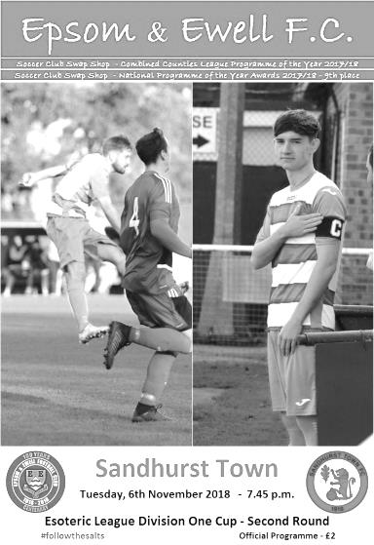
Our first ever match in the Division One League Cup was not of a great standard. However, it was ferociously competitive and you couldn't take your eyes off it for a minute, just in case something special happened.

Sandhurst Town came into this encounter on a six match winning run while we had won our last three, so both teams were high on confidence. They had a terrible journey over and some of their players were only able to have a brief warm up with real concern for a while that they may have to start with less than eleven, but everything was fine and they had the full complement, plus substitutes by the time we got under way.

We had a few changes to our line up with Liam Roberts, Reisse Griffin and new boy Jamie Watts all unavailable, while Scott Murphy continued his suspension and then Ryan Sullivan pulled up in the warm up with a recurrence of his foot injury. However, coming back after suspension were Elliott Thompson and Steve Betancourt, while Roy Gayle, a new signing from Guildford City made his debut and Scott Elgar came off the bench to replace Sullivan.

There is very little that I can write about the first half that is particularly positive. Despite the disruption to their pre-match routine, the visitors came at us like a train and pressed us at every opportunity, causing our possession to suffer and very little was created by our boys as a result. Haydon Richardson nearly opened the scoring as early as the third minute but Conor Young was down well to save for a corner and this set the pattern for the opening 45 minutes. Betancourt did well to block another opportunity ten minutes later with Young able to fall on the loose ball before our keeper was forced into another low save from the right hand channel, with the loose ball also being struck at goal but deflecting for a corner.

Another Sandhurst corner was met by an unmarked header but the ball fell easily for Young although we did finally manage a shot on target of our own in the 40th minute when Rob Hendry tried his luck from the edge of the area, although it wasn't that well struck and Ryan Howells in the visitors goal was down to save fairly comfortably. Then in first half injury time Luke Elgar made ground on the right, and squared the ball to Gayle who forced a save from Howells from 12 yards.

All that could be said in our favour as the players trooped off was that we had kept a clean sheet and were still very much in this contest. We needed to improve though, and going against the wind for the second period things did get slightly better. Although Betancourt picked up a yellow card for pulling back a visiting player who had just got through on goal we started to threaten from time to time ourselves and a David Jones corner after 53 minutes probably should have been knocked in by Gayle from six yards, although the ball came through a crowd of players and he may have seen it late. Sandhurst sent in a deep cross which was headed back across goal, but the ball was just too far

ahead of the incoming player who couldn't get his shot on target, before Thompson struck just wide of Howells' left hand post from 18 yards. He sliced the shot a little and the ball just skewed wider than intended or it would have been a great strike.

As the wind began to pick up Hendry was about a foot too high with a shot from around 25 yards and he was unfortunate in the 81st minute as Howells failed to reach a deep cross from the right and Gayle fed the ball back in for Hendry whose back flick at the near post went across goal and inches beyond the far post!

By this time Hendry was no longer playing at centre-forward as Germaine Jeannoel had replaced Thompson and was now playing as the front man. His more physical presence started to unruffle the steadying presence of Tom Cooper who had allowed Hendry very little room to operate. Now we threatened a bit more and although Sam Morgan replaced the injured Luke Elgar and Adam Heagney conceded a clumsy yellow card we were beginning to believe that this match could be won. Not in the 90 minutes though as Jeannoel seemed reluctant to shoot in injury time after running on to a Bennett pass and was blocked out. The whistle for the end of normal time sounded seconds later.

In extra time we continued to shoot against the wind during the first period and a good run from Betancourt resulted in the ball going out to Bennett with the right wing cross being met by the head of our defender who had continued his run, only to see the ball deflected wide for a corner. From the set piece Jones hit a powerful drive over the bar from the edge of the box. Luke Gaffney replaced the tiring Gayle who hadn't had too much football in recent weeks, but we were definitely finishing the stronger of the teams.

Bennett, looking as fresh as a daisy despite the exertions, sent over a right wing cross which Hendry got his head to. The ball bounced off a defender and fell to Gaffney on his stronger left foot, but from just six yards out he failed to make a proper contact on the ball and the first half of extra time concluded with the score remaining stubbornly goalless.

Spectators were beginning to wonder when we had last faced a penalty shootout (last November v Sutton Common Rovers by the way) and talk started heading towards who would be taking the penalties, but our boys had other ideas. Jeannoel shot into the keepers arms from 15 yards but then in the 108th minute he found room on the right. His ball in was behind the advancing strikers but was collected by Scott Elgar who fed the ball forward to Hendry whose shot on the turn went under the advancing Howells from ten yards out to put us ahead.

This goal raised the opposition to further efforts and Young made a good low save just a minute later. It would have been incredibly frustrating to have defended so well, only to concede a minute after breaking through, but it didn't happen and even an incredibly harsh second yellow card for Betancourt for kicking the ball away with three minutes to play, and despite one of the opposition players having done this on three occasions without penalty, made no difference as we collected our third clean sheet in four matches with the 1-0 win.

Although we weren't at our best, credit must be given to the opposition who looked very impressive for long periods of the match with exception of their finishing. Our defenders all played well and gave us the chance to remain in the competition, while Hendry's fifth goal in four matches ended up proving to be the difference as we entered the hat for the Quarter-Final draw; something I didn't think I'd get the chance to write at half time of this contest!

Epsom and Ewell: Conor Young, Luke Elgar, David Jones, Scott Elgar, Steve Betancourt, Lloyd Connelly, Elliott Thompson, Adam Heagney (c), Rob Hendry, Roy Gayle, Bobby Bennett

Subs: Germaine Jeannoel for Thompson (76), Sam Morgan for Luke Elgar (82), Luke Gaffney for Sullivan (98)

From behind the goal
Ash United 1-2 Epsom & Ewell
Combined Counties League - Division One - Saturday 10th November 2018

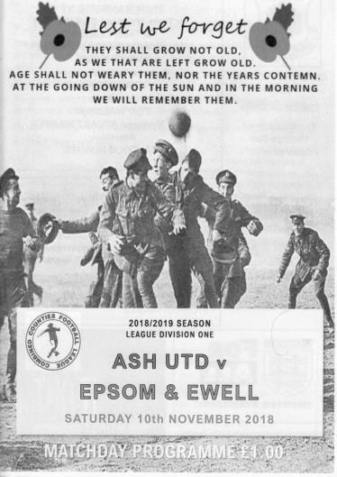
Five wins in a row as Salts see off Ash challenge

On a horrible, rainy day with matches being postponed and abandoned not too far away from us, our boys weathered the storm and everything the home side threw at us before taking control of the match and finishing deserved winners. In fact, had we not conceded a sloppy 90th minute goal I would have described this performance as thoroughly professional.

It was also nice for the first time in four matches to report that we finished with eleven men, with not even a yellow card on show in a match that was excellently refereed, although it always helps when the players commit to playing the game fairly and this was most definitely the case for both sets of players who tried their hardest on a surface that held up well, despite the weather.

With new Manager Simon Funnell taking charge for the first time since the club made the official announcement I thought we might start like a train in this match. Instead, we actually got off to a slightly rocky start. Conor Young was down low to make an early save in the fourth minute and two minutes later Jamie Watts misjudged the conditions and collided with an Ash player inside the box. He may have got some of the ball, but it looked clumsy and I wasn't surprised when the referee awarded the spot kick. Fortunately, Young guessed the right way and made a comfortable save from the penalty.

Another shot on the quarter hour mark rippled our side netting and we were taking our time to get into the match. Our first attempt on goal did not come until in the 26th minute when Adam Heagney, captaining the team for the third time in the absence of Murphy, delivered a free kick into the danger area where Rob Hendry was there first to head at goal, although a defender's head was there slightly afterwards to block the ball which looped up easily for the keeper Jamie Cunningham to collect.

The match became more even from that point and the key minute of the match was the 32nd, when the home team switched off and we had three opportunities, the third of which would result in the opening goal. Firstly, a Hendry free kick was just wide of the far post, although seconds later he robbed a defender and ran in on goal, unfortunately dragging his shot just beyond the far post. However, he was not to be denied and Bobby Bennett then robbed another defender, cutting in on goal from the right, drawing Cunningham before feeding Hendry who was able to knock the ball in from six yards into the vacant net.

We nearly scored a second after fit again Olly Martinez reached the touch line on the left and pulled the ball back to Roy Gayle, but his shot from ten yards just cleared the bar. In the 39th

minute Bennett made a similar run on the right, pulling the ball back for Hendry who twisted and turned before missing the far post by inches with his shot from just inside the box. I was behind the goal of course, and thought it was going in, so it must have been very close! Heagney then struck over the bar as we began to take control but were forced into a change in first half injury time when David Jones injured his ankle and had to go to hospital where we hope the damage was not as serious as it looked. Reisse Griffin dropped back to cover while Scott Elgar entered the fray.

Although the opening minutes had been a little laboured we were by this time full value for our lead and I felt that one more goal would probably finish the match as a contest. We opened up the second half showing that sort of intent and inside the opening minute Gayle flicked the ball on to Hendry who shot just wide of the near post. However, the second goal didn't come and we had a scare at the other end, but the shot that came in was very weak and didn't even reach the goal! Martinez nearly fed Hendry after a good run and pull back but the pass was intercepted while at the other end Young had to save a thirty yard free kick and then a low save from a shot from distance following a corner.

From a corner of our own in the 65th minute the ball came off a defender and fell to Lloyd Connelly whose shot on the turn went just over the bar but we finally extended our lead four minutes later when Martinez wriggled between two players and was upended by one of them. Bennett has a perfect record from the spot in his time with us, and this was his seventh successful strike from the spot already this season, but he will have been extremely thankful to see his penalty go straight under Cunningham who had guessed correctly. Cunningham was the last of just five keepers out of sixty to deny our former penalty king Kyle Hough from the penalty spot, but his luck wasn't in this time and it was 2-0. Cunningham blocked another powerful Bennett strike from an angle before Griffin played a clever one-two, collecting the return and running in on goal, but his shot lacked composure and he lashed the ball powerfully but wide of the post from 15 yards out.

The match was beginning to look like it would end in a comfortable away win although the final few minutes gave the hosts some hope as we appeared to tire. A long range shot was tipped over by Young who then had to be alert again in the 88th minute to catch a powerful free kick that appeared to go straight through our wall. Unfortunately we didn't heed the warnings and in the 90th minute the hosts pulled a goal back after we conceded a throw, but didn't react with the ball in from the right being knocked in by an unmarked striker.

This was the first goal we had conceded for 326 minutes, since our win at Chessington & Hook United and it was a pity that we couldn't hold on for the clean sheet, but on days like this it is important to just come home with the win and it must be remembered that of our fifteen League matches so far, only five of these have been played at home. We are now well and truly back in the promotion race, despite the removal of AC London from the League this weekend which will result in the loss of our 6-0 win from the table. There is still a long way to go but we are definitely on track right now and long may it continue!

Epsom and Ewell: Conor Young, Lloyd Connelly, David Jones, Reisse Griffin,
Jamie Watts, Steve Betancourt, Bobby Bennett, Adam Heagney (c), Rob Hendry,
Roy Gayle, Olly Martinez

Subs: Scott Elgar for Jones (45), Sam Morgan for Watts (72)
Germaine Jeannoel for Gayle (80)

This Day in History - 17th November
Date | Day | Competition |  | Opponents |  | Scorers
17/11/28 | Sat | London League | H | Cray Wanderers | 4-2 | F.Behn (2), W.Challis, G.Carmichael
17/11/34 | Sat | Amateur Cup 4q | A | Redhill | 1-1 | T.Dunne
17/11/45 | Sat | Surrey Senior Cup 1 | H | Carshalton Athletic | 7-3 | G.Brogdale (4), S.Tingey, R.Buller, R.Crowther
17/11/51 | Sat | Corinthian League | H | Uxbridge | 3-2 | R.Orford, B.Musto, T.Wright
17/11/56 | Sat | Corinthian League | H | Erith & Belvedere | 8-1 | J.Bangs (4), D.Hermitage (2), J.Sorensen, B.Jenkins
17/11/62 | Sat | Corinthian League | A | Slough Town | 0-2
17/11/73 | Sat | Surrey Senior League | H | Westfield | 2-1 | D.Ritman, K.Gregory
17/11/79 | Sat | Isthmian League 1 | H | Bishop's Stortford | 0-1
17/11/81 | Tue | Isthmian League 1 | A | Lewes | 2-1 | L.Peck, S.Hill
17/11/84 | Sat | Isthmian League  Premier Division | H | Harrow Borough | 2-0 | S.Hill (2)
17/11/90 | Sat | Isthmian League 2s | H | Newbury Town | 0-1
17/11/01 | Sat | Isthmian League 3 | A | Wokingham Town | 2-5 | B.Stevens, P.Sears
17/11/07 | Sat | Combined Counties Premier Division | H | Raynes Park Vale | 4-1 | R.Burns (2), D.Smith, G.McLaughlin
17/11/12 | Sat | Combined Counties Premier Division | H | Chessington & Hook United | 0-1
17/11/15 | Tue | Combined Counties Premier Division | A | Hartley Wintney | 3-3 | M.Ferdinando (2), T.Neale
Historical Decades
90 years ago – Epsom Town F.C.
17/11/28 | Sat | London League | H | Cray Wanderers | 4-2 | F.Behn (2), W.Challis, G.Carmichael
80 years ago – Epsom F.C.
19/11/38 | Sat | London League | H | Guildford City Reserves | 3-2 | G.Collins (2), B.Solly
70 years ago – Epsom F.C.
20/11/48 | Sat | London League | A | Ekco | 2-0 | F.Chitty, B.Cutter
60 years ago – Epsom F.C.
15/11/58 | Sat | Corinthian Memorial Shield 1 | A | Leatherhead | 1-3 | T.Millard
50 years ago – Epsom & Ewell F.C.
16/11/68 | Sat | Surrey Senior Cup 2q | A | Old Suttonians | 3-1 | R.Malyon (2), A.Parrott
40 years ago – Epsom & Ewell F.C.
16/11/78 | Thur | Southern Comb. Cup 1 | H | Wokingham Town | 0-3
30 years ago – Epsom & Ewell F.C.
19/11/88 | Sat | Isthmian League 2s | A | Camberley Town | 0-2
20 years ago – Epsom & Ewell F.C.
10/11/98 | Tue | F.A. Vase 1 replay | A | Stansted | 5-0 | M.Jones (3), S.Grant, M.Owen (pen)
10 years ago – Epsom & Ewell F.C.
15/11/08 | Sat | Combined Counties Premier Division | A | Raynes Park Vale | 5-3 | K.Hough (2, 1 pen), R.Burns (2), B.Hayward

History Corner – 17th November
84 years ago today we visited the Memorial Ground for an important Amateur Cup Final Qualifying Round tie. The two teams regularly met in this competition with Epsom in the ascendency in the early thirties, but matches were getting closer and in front of 2,500 they could not be separated; Tommy Dunne scoring our goal in a 1-1 draw. We would win the replay 3-1 the following Saturday at West Street, but Redhill would end our Amateur Cup run in the next four seasons. As a result, this progress represents our final visit to the First Round Proper where luck was still against us and we drew an away tie at eventual Finalists Wimbledon, who would beat us 2-0 in January 1935.

73 years ago today we hosted Carshalton Athletic in the Surrey Senior Cup. We went in to the match in high confidence, having defeated Acton 12-0 the previous week with Gordon Brogdale scoring four goals, and he would do it again this week as we thrashed the Robins 7-3 with Syd Tingey, R.Buller and R.Crowther getting the others. We used to defeat them heavily on a regular basis and have still scored more goals against them than any other club, but as with Redhill above, the times were changing and we have not beaten them since May 1955, a run of 63 years now!

62 years ago today our scoring sensation Johnny Bangs scored four more goals in our 8-1 demolition of Erith & Belvedere in a Corinthian League match. (see programme pictured) Oddly, the score was only 1-0 at half time and Ray Colfar missed a penalty or it would have been worse!
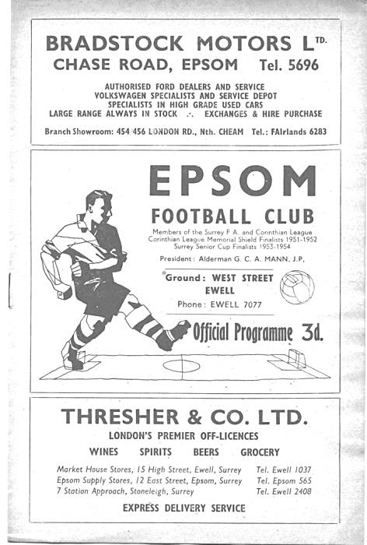
34 years ago today two Steve Hill goals were enough to defeat Harrow Borough in the Isthmian League Premier Division. It had taken two months to register the first win of the season, but this was the club’s third inside just two weeks.

20 years ago this week we made our only visit to Stansted for an F.A. Vase replay, following our 1-1 draw after extra time at Merland Rise. On a misty and quiet night we secured our path to the Second Round with a 5-0 victory there with Martin Jones scoring his only hat trick for the club. I recall the final goal quite clearly as he nonchalantly chipped the ball over the keeper from twenty yards! Fakenham Town would end our run a couple of weeks later with a late penalty.

11 years ago today although there had been a book signing seven days previously, the new Epsom and Ewell football club history “Two Legs Not Four” was officially released at our home game with Raynes Park Vale. Many former players were present as we defeated our local rivals 4-1 at Merland Rise that day.

3 years ago today we visited eventual League Champions Hartley Wintney and on a very blustery evening we managed to achieve a 3-3 draw, although it required a comeback from 3-1 down to get it. We had been the better side for much of the game but trailed early on before Matt Ferdinando scored with a wind assisted shot from 45 yards! It looked grim at 3-1 down though before Ferdinando scored with a free kick under the wall and then Tom Neale forced a loose ball in with just four minutes remaining to clinch the draw. We should have won though!

Centre page for results

Centre page for results

CCL Division One Club Directory
AC LONDON: Telephone: 0208 660 5491 - Colours: Orange/Black/Black
Ground: Whyteleafe FC - 15 Church Road, Whyteleafe. CR3 0AR

ASH UNITED: Telephone: 01252 344264 - Colours: Green with Red Trim/Green/Green
Ground: Shawfields Stadium, Youngs Drive, Shawfields Road, Ash, Aldershot. GU12 6RE

BAGSHOT: Telephone: 01252 623804 - Colours: Yellow/Black/Black
Ground: Fleet Town FC - Calthorpe Park, Crookham Road, Fleet. GU51 5FA

BEDFONT & FELTHAM: Telephone: 0208-890 7264 - Colours: Yellow/Blue/Blue

Ground: The Orchard, Hatton Road, Bedfont. TW14 9QT

BRITISH AIRWAYS: Telephone: 0208-890 7264 - Colours: Sky Blue/Navy Blue/Navy Blue
Ground: Bedfont & Feltham FC - The Orchard, Hatton Road, Bedfont. TW14 9QT

CHESSINGTON & HOOK UNITED: Telephone: 01372-602263 Colours: All Blue
Ground: Chalky Lane, Chessington. KT9 2NF

COVE: Telephone: 01252 543615 Colours: Yellow/Black/Black
Ground: Oak Farm, Squirrel Lane, Cove GU14 8PB

DORKING WANDERERS RES Telephone: 01306 400151 - Colours: Red & White Stripes/ Blue/ Red
Ground: Meadowbank Stadium, Mill Lane, Dorking. RH4 1DX

EPSOM & EWELL Telephone: 01737-553250 - Colours: Royal Blue & White Hoops/Royal Blue/Royal Blue - Ground: Chipstead FC, High Road, Chipstead. CR5 3SF

EVERSLEY & CALIFORNIA Telephone: 0118 973 2400 - Colours: - White & Royal Blue Hoops /Royal Blue/ Royal Blue - Ground: Fox Lane, off Reading Road, Eversley. RG27 0NS

FARNHAM TOWN Telephone: 01252 715305 - Colours: - Claret & Sky Blue /White/ Claret & Blue
Ground: Memorial Ground, Babbs Mead, West Street, Farnham. GU9 7DY

FC DEPORTIVO GALICIA Telephone: 0208 831 9067 - Colours: Royal Blue/Royal Blue/White
Ground: Bedfont Sports FC - Bedfont Sports Club, Hatton Road, Bedfont. TW14 9JR

FLEET SPURS Telephone: 01252 662810 - Colours: Dark Blue with Red Trim/Dark Blue/Dark Blue
Ground: Kennels Lane Farnborough. GU14 0ST

FRIMLEY GREEN Telephone: 01252 835089 - Colours: All Blue
Ground: Frimley Green Recreation Ground, Frimley Green Road, Frimley. GU16 6JY

GODALMING TOWN Telephone: 01483 417520 - Colours: Yellow/Green/Yellow
Ground: Wey Court, Meadrow, Godalming. GU7 3JE

KENSINGTON BOROUGH Telephone: 01372 360151 - Colours: All Blue
Ground: Leatherhead FC – Fetcham Grove, Guildford Road, Leatherhead. KT22 9AS

SANDHURST TOWN Telephone: 01252 878768 - Colours: Red & Black Stripes/Black/Black
Ground: Bottom Meadow, Sandhurst Memorial Park, Yorktown Road, Sandhurst. GU47 9BJ

SHEERWATER Telephone: 01483 772470 - Colours: Royal Blue & White/Royal Blue/Royal Blue
Ground: Woking FC - Laithwaite Community Stadium, Kingfield, Kingfield Road, Woking. GU22 9AA

TOOTING BEC Telephone: 0208 540 8843 - Colours: Black & White Stripes/White/White & Black
Ground: Raynes Park Vale FC – Prince George’s Playing Fields, Grand Drive, Raynes Park. SW20 9DZ

First Eleven Appearances 2018/19 - (max 21)
Name | Debut | 2018/19 |  |  |  | Career Totals
 |  | App | Sub | Tot | Goals | App | Sub | Tot | Goals
BENNETT Bobby | 12/08/2018 | 17 | 0 | 17 | 12 | 17 | 0 | 17 | 12
BETANCOURT Steve | 18/08/2018 | 17 | 1 | 18 | 1 | 17 | 1 | 18 | 1
BORRETT Ricky | 04/08/2018 | 9 | 0 | 9 | 0 | 9 | 0 | 9 | 0
CAMPBELL Kieran* | 29/09/2012 | 7 | 3 | 10 | 2 | 59 | 3 | 62 | 2
CAMPBELL Theo | 28/08/2018 | 2 | 9 | 11 | 1 | 2 | 9 | 11 | 1
CAULCRICK Joshua | 17/02/2018 | 0 | 3 | 3 | 0 | 0 | 4 | 4 | 0
CONNELLY Lloyd | 14/10/2017 | 22 | 0 | 22 | 4 | 52 | 4 | 56 | 5
DOBRAJ Endrit | 18/11/2017 | 5 | 2 | 7 | 1 | 24 | 6 | 30 | 1
DYSON Ben* | 12/08/2017 | 0 | 1 | 1 | 0 | 28 | 14 | 42 | 2
ELGAR Luke | 04/08/2018 | 4 | 3 | 7 | 1 | 4 | 3 | 7 | 1
ELGAR Scott | 12/08/2018 | 4 | 7 | 11 | 0 | 4 | 7 | 11 | 0
GAFFNEY Luke | 16/08/2014 | 2 | 2 | 4 | 0 | 12 | 3 | 15 | 0
GAYLE Roy | 06/11/2018 | 2 | 0 | 2 | 0 | 2 | 0 | 2 | 0
GILL George | 28/08/2018 | 2 | 0 | 2 | 0 | 2 | 0 | 2 | 0
GRIFFIN Reisse | 08/08/2015 | 13 | 0 | 13 | 2 | 117 | 13 | 130 | 10
HEAGNEY Adam | 16/08/2016 | 22 | 0 | 22 | 0 | 89 | 13 | 102 | 2
HENDRY Rob | 08/08/2015 | 7 | 0 | 7 | 6 | 91 | 23 | 114 | 34
JEANNOEL Germaine | 02/12/2017 | 0 | 7 | 7 | 2 | 2 | 14 | 16 | 3
JONES David | 31/08/2018 | 6 | 2 | 8 | 0 | 6 | 2 | 8 | 0
LOFTUS-CHEEK Joe | 06/08/2017 | 0 | 1 | 1 | 0 | 14 | 8 | 22 | 6
MARTINEZ Olly | 29/09/2018 | 4 | 1 | 5 | 1 | 4 | 1 | 5 | 1
MCKAY Alex | 20/12/2008 | 1 | 0 | 1 | 0 | 163 | 39 | 202 | 13
MORGAN Sam | 11/09/2018 | 1 | 4 | 5 | 0 | 1 | 4 | 5 | 0
MURPHY Scott | 20/01/2007 | 19 | 0 | 19 | 2 | 66 | 2 | 68 | 6
ROBERTS Liam | 12/08/2017 | 16 | 1 | 17 | 8 | 37 | 15 | 52 | 13
SMITH Taryn | 28/10/2017 | 6 | 6 | 12 | 5 | 14 | 10 | 24 | 5
SULLIVAN Ryan | 04/08/2018 | 12 | 1 | 13 | 0 | 12 | 1 | 13 | 0
SUTHERLAND Mitchel | 04/08/2018 | 1 | 1 | 2 | 0 | 1 | 1 | 2 | 0
THOMPSON Elliott | 09/02/2016 | 16 | 1 | 17 | 0 | 26 | 10 | 36 | 1
WATTS Jamie | 03/11/2018 | 2 | 0 | 2 | 0 | 2 | 0 | 2 | 0
WHITE Sean | 02/08/2014 | 9 | 4 | 13 | 4 | 29 | 25 | 54 | 9
WOODCOCK Josh | 22/09/2018 | 1 | 0 | 1 | 0 | 1 | 0 | 1 | 0
WRIGHT Kieran* | 15/09/2018 | 3 | 3 | 6 | 0 | 3 | 3 | 6 | 0
YOUNG Conor | 07/03/2015 | 10 | 0 | 10 | 0 | 43 | 0 | 43 | 0
* - Player has left the club

Combined Counties League Premier Division
Opponents All-time Records
inc Saturday  10th November | P | W | D | L | F | A | PPG | GD | Best  Win | Worst  Loss
Bedfont & Feltham | 2 | 2 | 0 | 0 | 13 | 3 | 3.00 | +10 | 9-2 | -
AC London | 1 | 1 | 0 | 0 | 6 | 0 | 3.00 | +6 | 6-0 | -
Bagshot | 2 | 2 | 0 | 0 | 4 | 0 | 3.00 | +4 | 3-0 | -
FC Deportivo Galicia | 1 | 1 | 0 | 0 | 3 | 0 | 3.00 | +3 | 3-0 | -
Tooting Bec | 1 | 1 | 0 | 0 | 3 | 1 | 3.00 | +2 | 3-1 | -
Fleet Spurs | 1 | 1 | 0 | 0 | 3 | 2 | 3.00 | +1 | 3-2 | -
Frimley Green | 11 | 9 | 1 | 1 | 35 | 5 | 2.55 | +30 | 7-1 | 0-1
Godalming Town | 3 | 2 | 0 | 1 | 4 | 5 | 2.00 | -1 | 2-1 | 0-3
Ash United | 20 | 11 | 3 | 6 | 50 | 32 | 1.80 | +18 | 6-0 | 0-3
Farnham Town | 18 | 9 | 4 | 5 | 31 | 29 | 1.72 | +2 | 3-0 | 1-4
Cove | 35 | 16 | 9 | 10 | 78 | 57 | 1.63 | +21 | 7-0 | 1-6
Chessington & Hook Utd | 30 | 13 | 9 | 8 | 63 | 45 | 1.60 | +18 | 6-0 | 1-3
Sheerwater | 5 | 2 | 2 | 1 | 10 | 5 | 1.60 | +5 | 3-0 | 2-3
Sandhurst Town | 16 | 7 | 0 | 9 | 28 | 28 | 1.31 | 0 | 4-0 | 1-3
British Airways | 1 | 0 | 0 | 1 | 2 | 3 | 0.00 | -1 | - | 2-3
Dorking Wanderers Res | 1 | 0 | 0 | 1 | 3 | 5 | 0.00 | 0 | - | 3-5
Eversley & California | 0 | 0 | 0 | 0 | 0 | 0 | 0.00 | 0 | - | -
Kensington Borough | 0 | 0 | 0 | 0 | 0 | 0 | 0.00 | 0 | - | -

Kensington Borough F.C. – History
Established as A.F.C. Hillgate in 2012, the club joined the Middlesex County League. In 2013–14 they finished third in Division Two, earning promotion to Division One Central and East.
After finishing sixth in Division One Central and East in 2014–15, they switched to Division Two of the Spartan South Midlands League. A fifth-place finish in 2015–16 saw them promoted to Division One.
In the summer of 2016 they were renamed Kensington Borough. At the end of the 2016–17 season the club were moved to Division One of the Combined Counties League.

Having previously played at the Linford Christie Stadium in White City, the club moved to Avenue Park Stadium in Greenford for the 2015–16 season. They moved to Spratleys Meadow in Amersham for the 2016–17 season and then to the Orchard in Bedfont for the following season.

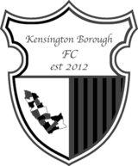
Prior to the 2018–19 season the club relocated to Leatherhead's Fetcham Grove, home of Leatherhead FC.

Player Sponsorship
Here is the latest list for 2018/19, with new photos showing all of our players and Management that are available for sponsorship.

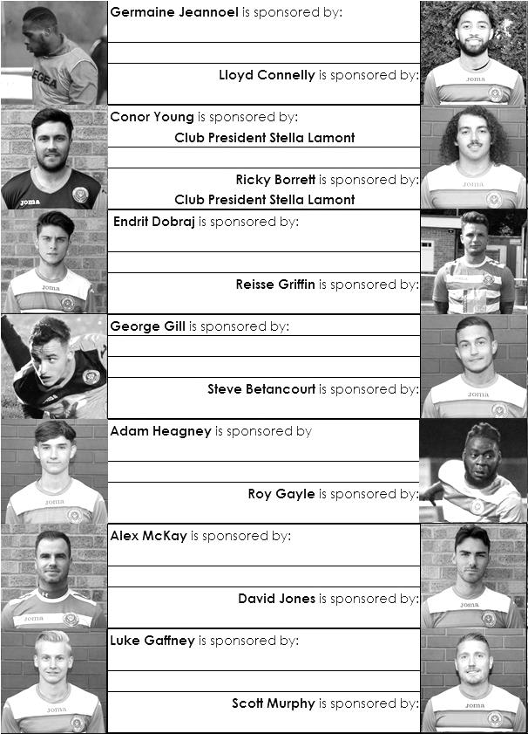

Sponsorship costs just £40 and it is easy to do. Just select a player who has not been previously sponsored and let a Committee Member know that you would like to sponsor them. Beware though. Until we have received the money it is possible for someone to jump in front of you, so don’t delay, sponsor today!

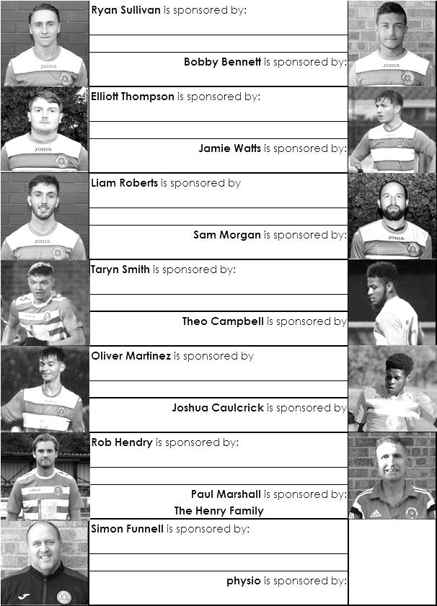

How we stand – Locally and Nationally – inc Sat 10/11/18
Here is the latest update on where we all stand. To summarise for new readers, there are 28 promotion places currently available at Step Six, with 358 teams battling away for those spots. The Champions of each League are guaranteed a promotion, with the best nine runners-up also going up. This number looks as though it will rise by three due to no likely promotions from the South West Peninsula League and the expected but not yet confirmed folding of Isthmian League Thamesmead Town, but this could all change still. For now we’ll continue to look at the 28 and anything else will be a bonus!

In our previous issue, we were listed as 93rd Nationally but since then we have defeated Frimley Green and Ash United and now sit in 72nd place.

Below is our current League table sorted by points per game, while across the page we have the overall top ten and most importantly the 28 clubs who would go up if the season ended right now.

Sheerwater, currently holding the runners-up spot in our League on points per game, have the 18th best record of the 19 second placed teams. Our league is so competitive right now that it may well prove to be just the Champions that go up, but I’ll keep updating the position here while we remain involved.

Combined Counties League Division One Table – by PPG
 | Pld | W | D | L | Pts | GD | PPG | Pos
Bedfont & Feltham | 14 | 10 | 3 | 1 | 33 | +37 | 2.36 | 1
Sheerwater | 16 | 10 | 3 | 3 | 33 | +15 | 2.06 | 2
Farnham Town | 15 | 9 | 3 | 3 | 30 | +19 | 2.00 | 3
Epsom & Ewell | 15 | 10 | 0 | 5 | 30 | +17 | 2.00 | 4
AC London | 15 | 9 | 2 | 4 | 29 | +11 | 1.93 | 5
Frimley Green | 15 | 8 | 5 | 2 | 29 | +6 | 1.93 | 6
Sandhurst Town | 14 | 8 | 3 | 3 | 27 | +1 | 1.93 | 7
Ash United | 15 | 7 | 4 | 4 | 25 | +13 | 1.67 | 9
Tooting Bec | 16 | 8 | 2 | 6 | 26 | +7 | 1.63 | 8
Dorking Wanderers Res | 16 | 7 | 4 | 5 | 25 | +3 | 1.56 | 10
Chessington & Hook Utd | 15 | 6 | 2 | 7 | 20 | -4 | 1.33 | 12
British Airways | 17 | 6 | 4 | 7 | 22 | -2 | 1.29 | 11
Eversley & California | 13 | 5 | 0 | 8 | 15 | -4 | 1.15 | 13
Godalming Town | 13 | 3 | 2 | 8 | 11 | -14 | 0.85 | 14
Kensington Borough | 15 | 3 | 2 | 10 | 11 | -18 | 0.73 | 15
Fleet Spurs | 13 | 3 | 0 | 10 | 9 | -13 | 0.69 | 17
Bagshot | 16 | 3 | 2 | 11 | 11 | -45 | 0.69 | 16
FC Deportivo Galicia | 14 | 2 | 2 | 10 | 8 | -8 | 0.57 | 18
Cove | 13 | 1 | 1 | 11 | 4 | -21 | 0.31 | 19

Step Six Table – by PPG – Top 10
 | Which League? | Pld | Pts | GD | PPG | Current Pos.
Cheltenham Saracens | HellW | 7 | 21 | 26 | 3.00 | 1
Selston | E.Mids | 16 | 44 | 36 | 2.75 | 1
Tividale | W.Mids | 18 | 49 | 58 | 2.72 | 1
Sherwood Colliery | E.Mids | 15 | 40 | 34 | 2.67 | 3
Harefield United | SSML | 12 | 32 | 29 | 2.67 | 1
Racing Club Warwick | Midland | 13 | 34 | 37 | 2.62 | 2
Thame Rangers | HellE | 5 | 13 | 10 | 2.60 | 3
Longridge Town | NWCN | 17 | 44 | 50 | 2.59 | 1
Anstey Nomads | UCL | 12 | 31 | 36 | 2.58 | 1
Lutterworth Town | UCL | 12 | 31 | 35 | 2.58 | 2
Epsom & Ewell | We are 72nd | 15 | 30 | +17 | 2.00 | 4

Step Six Table – The 28 Promoted Clubs if the season ended today
The 19 Champions – Based on current PPG
 | Which League? | Pld | Pts | GD | PPG | Current Pos.
Cheltenham Saracens | HellW | 7 | 21 | 26 | 3.00 | 1
Selston | E.Mids | 16 | 44 | 36 | 2.75 | 1
Tividale | W.Mids | 18 | 49 | 58 | 2.72 | 1
Harefield United | SSML | 12 | 32 | 29 | 2.67 | 1
Racing Club Warwick | Midland | 13 | 34 | 37 | 2.62 | 2
Thame Rangers | HellE | 5 | 13 | 10 | 2.60 | 3
Longridge Town | NWCN | 17 | 44 | 50 | 2.59 | 1
Anstey Nomads | UCL | 12 | 31 | 36 | 2.58 | 1
AFC Varndeanians | Scomb | 12 | 31 | 23 | 2.58 | 2
Welling Town | SCEFL | 15 | 38 | 25 | 2.53 | 1
Amesbury Town | Wess | 15 | 38 | 22 | 2.53 | 1
Harleston Town | EastN | 16 | 40 | 31 | 2.50 | 1
White Ensign | EastS | 15 | 37 | 30 | 2.47 | 1
Billingham Town | Northern | 15 | 37 | 29 | 2.47 | 1
Tavistock | SWP | 14 | 34 | 28 | 2.43 | 2
Cheddar | Western | 11 | 26 | 27 | 2.36 | 3
Bedfont & Feltham | CCL | 14 | 33 | 37 | 2.36 | 1
Winterton Rangers | NCEL | 15 | 35 | 25 | 2.33 | 1
Rylands | NWCS | 15 | 34 | 35 | 2.27 | 2
The 9 Best Runners-Up
Sherwood Colliery | E.Mids | 15 | 40 | 34 | 2.67 | 3
Lutterworth Town | UCL | 12 | 31 | 35 | 2.58 | 2
Easington Sports | HellW | 7 | 18 | 16 | 2.57 | 3
AFC Stoneham | Wess | 12 | 30 | 41 | 2.50 | 4
Steyning Town | Scomb | 12 | 30 | 19 | 2.50 | 3
Broadfields United | SSML | 13 | 32 | 21 | 2.46 | 2
Abingdon Town | HellE | 5 | 12 | 10 | 2.40 | 5
Exmouth Town | SWP | 13 | 31 | 26 | 2.38 | 6
Carlisle City | NWCN | 17 | 40 | 18 | 2.35 | 2

Previous Managers
In our latest instalment we cover the two men that followed Fred Chitty following his resignation in 1959.

Tommy Rochester – Manager 17th January 1959 - May 1959
Bill Kennedy – Aug 1959 – 6th February 1961

In August of 1959 the club made a mistake which almost proved fatal, although they wouldn’t realise it for another 15 years!

John Martin had become a club Vice-President in 1957/58 and the following season had become President of the Club. He was described by many, including former players Micky Williams and Norman Dearlove as a very generous man who would never let anyone else buy the drinks! He lived in tax exile on the Isle of Man but visited in his green Rolls Royce and took a real interest in the club.

He was a very rich man who had made money during the war with consumables like Martin’s Jam and the better known Carnation Milk. He visited South America occasionally on business and “had a finger in every pie”. Why exactly he wanted to get involved with our club is something I’ve been unable to find out, but he was clearly very committed at one point. He would slip extra £5 notes in the boots of players like Dearlove when he scored goals and in one particularly interesting story, tried to get Dearlove back from Sutton United in 1960 by offering him a deposit on a house and a £500 cheque that he wrote out then and there in Collingwood Recreation Ground!

However, the club’s mistake was in selling the ground to him in 1959 with just a fifteen year lease. This would become a real issue when it expired in 1974 and he would try to sell the ground for housing and evict the club. We were very fortunate to avoid this, thanks mainly to the Council refusing to allow planning permission on the West Street site at the time and Martin would eventually sell to Matthews Holdings, the forerunners of our current club Directors.

It is not clear whether Martin had anything to do with the departures of both Manager Fred Chitty and Chairman Peter Carpenter in January of 1959 but you would think that he would have had a say either in this, or in the appointment of their replacements. George Tarran a local pub landlord became Chairman, whilst into the Manager’s position came Tommy Rochester.

Tommy was born on 22nd August 1914 and was a local legend. He is pictured to the left in our final match of the 1938/39 season. The club had paid the Army £25 to buy him out of his job there and he later worked at the Manor Hospital. He was a great player with a strong shot in both feet and scored 54 goals in just 135 matches in his time playing for us, which spanned World War Two, so under normal circumstances would have played many more.

He had rejoined the club in July 1958 after a spell playing and Coaching at County League sides back then like Leatherhead, Surbiton Town and Ashtead so this was a bit of step up. He was made part of a three man Selection Committee, none of which were the Chairman it is interesting to note. Rochester was joined by popular Reserve Team Manager Ray Chenery and Press Secretary Ken Knowlson who had played at a decent Junior level although without making the move up.

However, results didn’t go well and Rochester left the club in the close season, quoting domestic circumstances. It was a sad end, although one of his sons Danny would play for the Reserves in future years. Tommy died in the Spring of 1977 at the age of just 62.

Bill Kennedy replaced him in the August of 1959. Formerly “a fully qualified Coach with a pass from Lilleshall” according to our programme, he had been at Molesey and Kingstonian and had a professional playing career of some quality, being at Stirling Albion before making the step up to Hibernian and later Millwall. He brought over a few players from Molesey in Les Cook, Alan Clift and Tony Davis, but none of them reached ten appearances with the club. In fairness to Kennedy, this was partly because John Martin clearly chose to “invest” unofficially in the club, as it might have been called back in those Amateur days, and better players were attracted quickly.

Off the field a group of Club Directors were created, with Tarran joined by new Secretary Peter Carpenter and the soon to become very famous Kenneth Wolstenholme, who lived around the corner! Almost immediately the standard seemed to improve. Former Surrey and Isthmian League representative player Johnny Blizzard joined from Tooting & Mitcham United where a broken leg had denied him the chance to be involved with their great FA Cup run the previous season. He was joined by John Ryan and Ken McDonald from Hounslow. The latter was a Scottish Amateur International and had chosen to join Epsom over Hendon but apparently the travel time to Heathrow Airport, where he worked, was better. If this was an issue, you wondered why he left Hounslow in the first place, while Blizzard was quoted as joining because “he liked the tea here”!

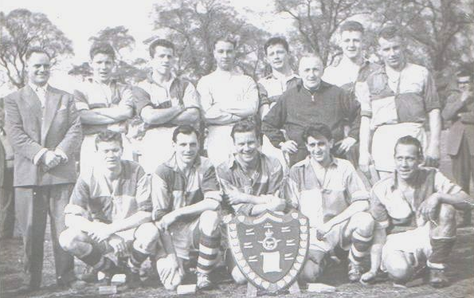
Peter Wood joined in October, vastly experienced from his time at Banstead Athletic and then Kingstonian before the final piece in the jigsaw arrived in January with the arrival of Norman Dearlove, a superb striker who scored dozens of goals each season and would rattle up 25 in just seventeen appearances this year as we would go on to win the Corinthian League Memorial Shield (which was the League Cup) with a 2-0 win over Maidenhead United at Vale Farm, Wembley FC.

The arrivals came too late to give us a serious run at the League title, but a fourth place finish was achieved and the club were confident that the sixties would turn into something special. It would not. In fact something was seriously amiss. In Committee Minutes dated 18th October 1960 it was reported that the Committee had approached John Martin about replacing the Coach. He advised them to wait until they had “a suitable replacement”. Clearly there was an issue between him and the Committee and once former Hounslow and England International Derek Evans joined the club in January 1961, clearly with an eye on getting into Management, the Committee moved, sacking Kennedy on 6th February 1961 and replacing him with Evans. They were in such a hurry to dispense with him that they even paid him £42 that he was alleged to be owed with no questions asked!

I do not know what went so disastrously wrong between the summer of 1960 and the October, which led our Committee to come to this decision, although some of our Cup heroes had already departed, while others wouldn’t remain long. It was a prelude to a dismal decade.

Kennedy is on the left in this photo with the Memorial Shield from April 1960.

EL Records Premier Challenge Cup
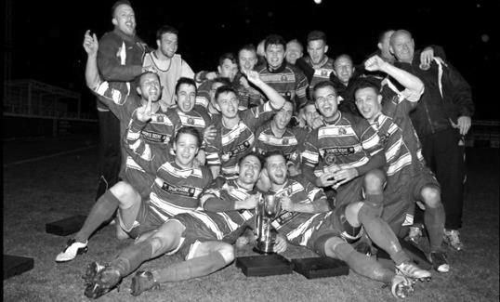
First Round
Camberley Town | 1-3 | Cobham
Horley Town | 0-1 | Chertsey Town
Badshot Lea | 3-1 | Walton & Hersham
FC Deportivo Galicia | 4-1 | Cove
Chessington & Hook United | 2-4 | AFC Hayes
Farnham Town | 1-2 | Southall
Hanworth Villa | 3-1 | Kensington Borough
Second Round
Bedfont & Feltham | 2-0 | Tooting Bec
Sheerwater | 1-0 | Balham
Ash United | 2-3 | Fleet Spurs
Frimley Green | 0-2 | Guildford City
Godalming Town | 2-0 | Dorking Wanderers Reserves
Abbey Rangers | 3-0 | Redhill
FC Deportivo Galicia | 5-0 | AC London
Cobham | 0-3 ABAN 88 | AFC Hayes
CB Hounslow United | 4-1 | Badshot Lea
Hanworth Villa | 2-1 | Sandhurst Town
Epsom & Ewell | 1-0 | Bagshot
Sutton Common Rovers | 4-2 | Southall
Chertsey Town | 3-2 | British Airways
Eversley & California | 1-5 | Knaphill
Banstead Athletic | 4-3 | Colliers Wood United
Spelthorne Sports | 2-1 | Raynes Park Vale

Match and Ball Sponsorships – 2018/19
Opponent | Date | Match Sponsor | Ball Sponsor
Chessington & Hook Utd | 21/08/18 | Club President - Stella Lamont
Beckenham Town (FAC) | 28/08/18 | Building Shop Ltd
Cove | 08/09/18 | EEFC Management Committee
Tooting Bec | 15/09/18 | Building Shop Ltd
Bagshot (LC) | 25/09/18
Sheerwater | 06/10/18 | Paul Merritt
Knaphill U23  (Surrey Premier Cup) | 23/10/18 | Jack Jarman
Frimley Green | 03/11/18 | Our Chairman’s Grandchildren – George, Joseph, Ezara and Inaya
Sandhurst Town (LD1C) | 06/11/18 | Richard Lambert
Kensington Borough | 17/11/18 | Jeff & Arnold Pye
Dorkinian (SPC) | 20/11/18
Dorking Wanderers Res | 27/11/18
Godalming Town | 01/12/18
Bedfont & Feltham | 08/12/18
Eversley & California | 29/12/18
Ash United | 12/01/19
Bagshot | 19/01/19
Farnham Town | 02/02/19
British Airways | 16/02/19
AC London | 02/03/19
FC Deportivo Galicia | 12/03/19
Fleet Spurs | 06/04/19
Sandhurst Town | 20/04/19 | Club President - Stella Lamont
Unknown (LC) |  | 3rd Round – might be at home
Unknown (LD1C) |  | 3rd Round – might be at home
Match sponsorship costs just £60.00!

Sponsorship includes:

Admission, programmes and hospitality for three people.

A full page advert in the programme and mascot for the day (if required).

If you are interested, just speak to a Committee Member,
or drop me an email at: richard.c.lambert@gmail.com

Combined Counties League - Division One
Saturday, 17th November 2018 - Kick-off 3.00 p.m.
Epsom and Ewell  (Royal Blue & White hoops) | V |  | Kensington Borough  (All Red)
Squad | NUMBERS |  | Squad
Conor Young |  |  | Hayden Graham
Ricky Borrett |  |  | Terry Whitman
Luke Elgar |  |  | John Davite
Reisse Griffin |  |  | Gilbert Batousol
Lloyd Connelly |  |  | Emanuel Agbor
Jamie Watts |  |  | Magnus Rose
Steve Betancourt |  |  | Richard Okrah Jr
David Jones |  |  | Nigel Siedu
Endrit Dobraj |  |  | Sebastian Philogene
Adam Heagney |  |  | Ricardo Adewuyi
Ryan Sullivan |  |  | Terrance Cariba
Liam Roberts |  |  | Ashley Flanore
© Scott Murphy |  |  | Kevin Baffour Awuah
Scott Elgar |  |  | Ali Awil
Elliott Thompson |  |  | Ahmed Jibz
Bobby Bennett |  |  | Kelvin Odoru
Rob Hendry
Roy Gayle
Olly Martinez
Germaine Jeannoel
Joshua Caulcrick
Taryn Smith
Simon Funnell | MANAGER |  | Mo Bakkali / Mike Edghill
Matt Drew | ASST MANAGER |  | Jeff Clement
Sam Morgan | COACHES
 | PHYSIO |  | Kylie Edghill
REFEREE: S.Idris
ASSISTANTS: R van Niekerk, D,Merrick
Today’s match is sponsored by
Long serving supporters Jeff and Arnold Pye

OUR NEXT VISITORS TO HIGH ROAD
Dorkinian F.C.
Surrey Premier Cup – Second Round
Tuesday, 20th November 2018 – 7.45 pm

